**A.Simple programs**

**1.Write a program in python to add two numbers and print the result.**

**Code:**

**#Program to find the sum of two numbers**

**a=int(input("Enter first number"))**

**b=int(input("Enter second number"))**

**sum=a+b**

**print("Sum of two numbers is",sum)**

**Output:**

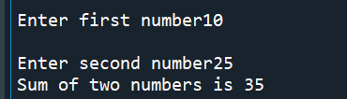

**2. Write a program in python to find the area of a triangle.**

**import math.**

**Code:**

**#Program to find area of triangle using Herons formula**

**a=int(input("Enter first side"))**

**b=int(input("Enter second side"))**

**c=int(input("Enter third side"))**

**s=(a+b+c)/2**

**d=s*(s-a)*(s-b)*(s-c)**

**area=math.sqrt(d)**

**print(“Area of triangle is “,area)**

**Output:**

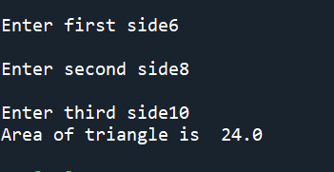

**3Write a program in python to find square root of a number.**

**Code:**

**#Program to find square root of a given number**

**N=int(input("Enter the number"))**

**sqrt=0**

**q=False**

**for i in range(0,N):**

**sqrt=i*i**

**if(sqrt==N):**

**q=True**

**break**

**if(q==True):**

**print("Square root of number is",i)**

**else:**

**print("Number does not have a integral square root")**

**Output:**

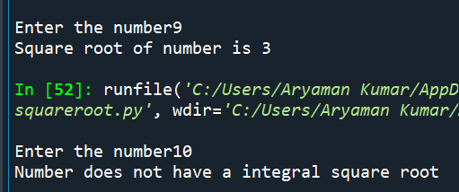

**4. Write a program in python to solve a quadratic equation.**

**Code:**

**#Program to find the roots of a quadratic equation**

**import math**

**a=int(input("Enter a value"))**

**b=int(input("Enter b value"))**

**c=int(input("Enter c value"))**

**D=b**2-4*a*c#Calculating discriminant**

**if(D<0):**

**print("Imaginary roots")**

**else:**

**x1=(-b+math.sqrt(D))/2*a#Calculating the two roots**

**x2=(-b-math.sqrt(D))/2*a**

**print("roots",x1,x2)**

**Output:**

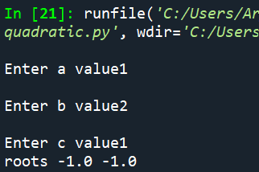

**5. Write a program in python to convert Fahrenheit to Celsius.**

**Code:**

**#Program to convert temperature given in Farenheit to Celsius**

**t=float(input("Enter temperature in farheneit"))**

**C=5/9*(t-32)**

**print("Temperature in Celsius is",C)**

**Output:**

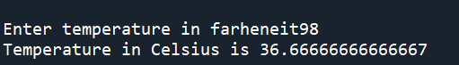

**6. Write a program in python to find quotient and reminder after division.**

**Code:**

**#Program to display quotient and remainder after division**

**a=int(input("Enter first number"))**

**b=int(input("Enter second number"))**

**q=a//b**

**r=a%b**

**print("Quotient",q)**

**print("Remainder",r)**

**Output:**

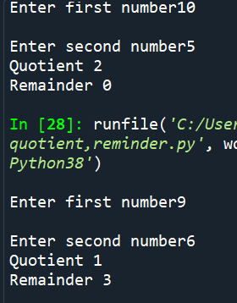

**7. Write a program in python to swap two numbers using tuple assignment.**

**Code:**

**#Program to swap the values of numbers using tuple assignement**

**a=int(input("Enter the first number"))**

**b=int(input("Enter the second number"))**

**print("Before swap",a,b)**

**t=a,b**

**b,a=t**

**print("After swap",a,b)**

**Output:**

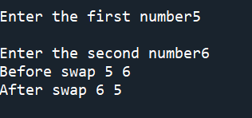

**8. Write a program in python to find the average of three marks.**

**Code:**

**#Program to calculate the average of the marks of a student in three subjects**

**a=int(input("Enter marks in first subject"))**

**b=int(input("Enter marks in second subject"))**

**c=int(input("Enter marks in third subject"))**

**avg=(a+b+c)/3**

**print("Average of three marks",int(avg))**

**Output:**

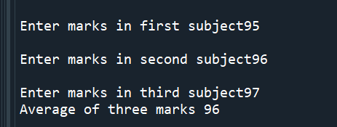

**9. Write a program in python to calculate simple interest.**

**Code:**

**#Program to calculate simple interest**

**P=int(input("enter the principal"))**

**r=int(input("enter the rate"))**

**t=int(input("enter time period"))**

**SI=P*r*t//100**

**print("Simple interest",SI)**

**Output:**

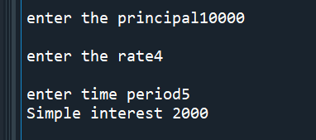

**10. Write a program in python to calculate the net pay given basic pay, hra, da and deductions.**

**Code:**

**#Program to calculate net pay of the user**

**bp=int(input("Enter basic pay"))**

**hra=int(input("Enter HRA amount"))**

**da=int(input("Enter DA amount"))**

**de=int(input("Enter amount of deductions"))**

**net=bp-(hra+da+de)**

**print("Net pay",net)**

**Output:**

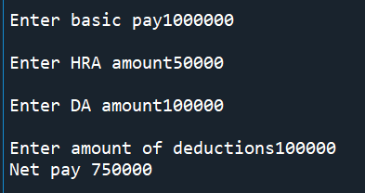

**B. Programs using Conditional Statements**

**1. Given age determine whether a person is eligible to vote or not. (if else)**

**Code:**

**#Program to check whether a person is eligible to vote or not**

**age=int(input("Enter voter age"))**

**if(age>=18):#person is eligible to cote if age is greater than 18**

**print("Eligible to vote")**

**elseprint("Uneligible to vote")**

**Output:**

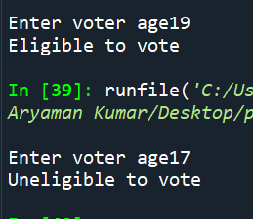

**2. Check whether a number is odd or even. (if else)**

**Code:**

**#Program to check if a given number is odd or even**

**a=int(input('Enter number'))**

**if(a%2==0):**

**print("even")**

**else:**

**print("odd")**

**Output:**

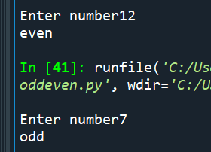

**3. Write a program to find largest of two numbers. (if else)**

**Code:**

**#Program to compare two numbers and tell which one is greatest**

**a=int(input("Enter the first number"))**

**b=int(input("Enter the second number"))**

**if(a>b):**

**print("First number",a,"is greatest")**

**else:**

**print("Second number",b,"is greatest")**

**Output:**

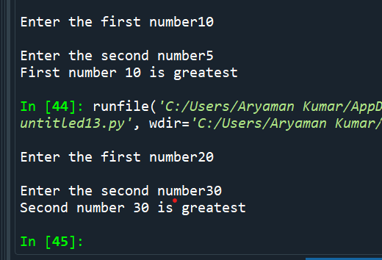

**4. Obtain a character convert lower case to uppercase and vice versa. (if else)**

**Code:**

**#Program to convert uppercase to lowercase and vice versa**

**a=input("Enter text")**

**if(a.islower()==True):**

**cc=a.upper()#Converting lowercase to uppercase**

**print(cc)**

**print("Converted to uppercase")**

**else:**

**cc=a.lower()#Converting uppercase to lowercase**

**print(cc)**

**print("Converted to lowercase")**

**Output:**

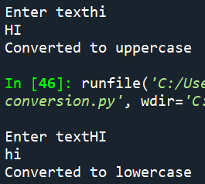

**5. Find the input year is leap year or not. (if else)**

**#Program to find out whether a given year is a leap year**

**Code:**

**n=int(input("Enter the year"))**

**if(n%100==0):**

**if(n%400==0):#If a leap year is also divisible by 100 then it has to**

**#be divisible by 400 to be a leap year**

**print("It is leap year")**

**else:**

**print("It is not a leap year")**

**elif(n%4==0):#If a year not divisible by 100 is divisible by 4 it is a**

**#leap year**

**print("It is leap year")**

**else:**

**print("It is not a leap year")**

**Output:**

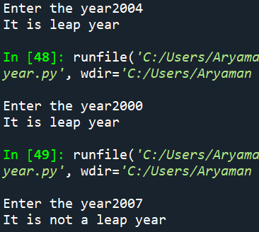

**6. Read a number, check if it is positive, negative or zero. Increment the number if it is positive, decrement if it is negative. (elif statement)**

**Code:**

**#Program checks whether a given number is positive,negative or zero and increments the number if it is positive and decrements it if negative.Number is unchanged if it is zero.**

**n=int(input("Enter the number"))**

**if(n>0):**

**n=n+1#If number is positive ,it is incremented**

**print(n)**

**elif(n<0):**

**n=n-1#If number is negative it is decremented**

**print(n)**

**else:**

**print(n)**

**Output:**

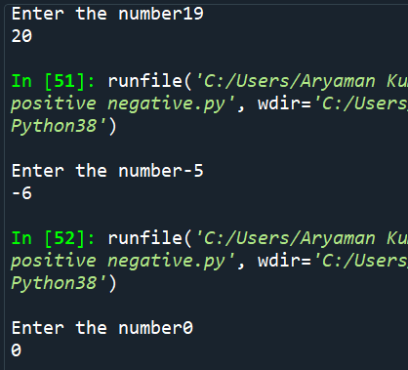

**7. Create a simple calculator. (elif statement)**

**Code:**

**#Program to make a simple calculator that can add,subtract,multiply and divide two numbers**

**a=int(input("Enter first number"))**

**b=int(input("Enter second number"))**

**ch=int(input("Enter your choice 1.Addition,2.Subtraction,3.Multiplication,4 division"))**

**if(ch==1):**

**c=a+b**

**print("Result",c)**

**if(ch==2):**

**c=a-b**

**print("Result",c)**

**if(ch==3):**

**c=a*b**

**print("Result",c)**

**if(ch==4):**

**c=a/b**

**print("Result",c)**

**Output:**

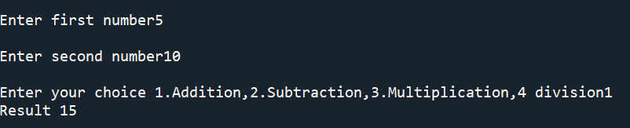 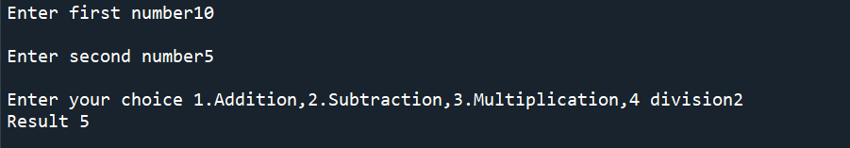

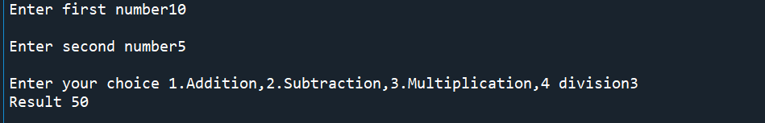 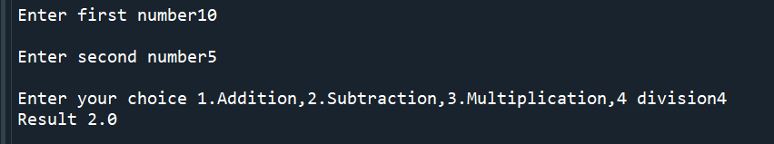

**8. Estimate the Grade based on the marks obtained by a student. (elif statement)**

**Code:**

**#Program to calculate grade of student based on marks**

**marks=int(input("Enter the marks of the student"))**

**if(marks>=90):**

**print("A")**

**elif(marks>=70 and marks<90):**

**print("B")**

**elif(marks>=50 and marks<70):**

**print("C")**

**elif(marks>=35 and marks<50):**

**print("D")**

**else:**

**print("E")**

**Output:**

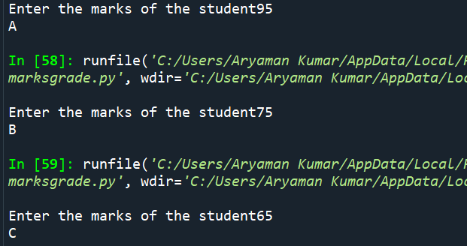 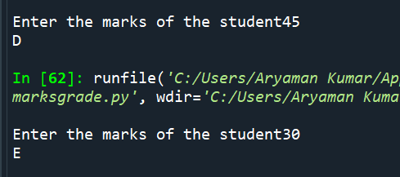

**9. Find the largest of 3 numbers. (elif statement)**

**Code:**

**#Program to find out the greatest number among three numbers**

**n1=int(input("Enter first number"))**

**n2=int(input("Enter second number"))**

**n3=int(input("Enter third number"))**

**if(n1>n2 and n1>n3):**

**print(n1,"n1 is greatest")**

**elif(n2>n1 and n2>n3):**

**print(n2,"n2 is greatest")**

**else:**

**print(n3,"n3 is greatest")**

**Output:**

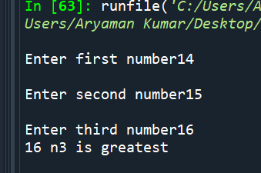

**10. Obtain a character, check if it is lower case, uppercase or digit. (elif statement)**

**Code:**

**#Program to find whether input character is uppercase,lowercase or digit**

**a=input("Enter character")**

**if(a.islower()==True):**

**print("Character is lowercase")**

**elif(a.isupper()==True):**

**print("Character is Uppercase")**

**elif(a.isdigit()==True):**

**print("Character is a digit")**

**Output:**

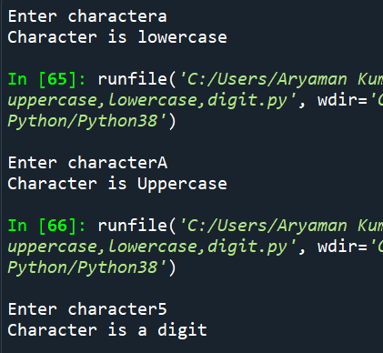

**Write the output that you obtain for the following Python questions.**

**1.Write a program to check whether a number is odd or even.**

**Code:**

**#Program to check if a given number is odd or even**

**a=int(input('Enter number'))**

**if(a%2==0):**

**print("even")**

**else:**

**print("odd")**

**Output:**

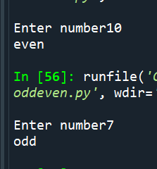

**2. Write a program in python to find the biggest of two numbers.**

**Code:**

**#Program to compare two numbers and tell which one is greatest**

**a=int(input("Enter the first number"))**

**b=int(input("Enter the second number"))**

**if(a>b):**

**print("First number",a,"is greatest")**

**else:**

**print("Second number",b,"is greatest")**

**Output:**

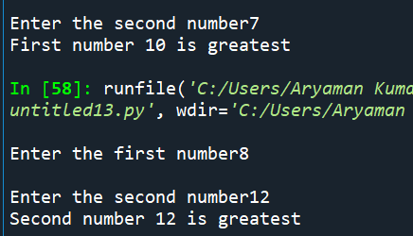

**3. Write a program to convert a character from lower case to uppercase and vice versa.**

**Code:**

**#Program to convert uppercase to lowercase and vice versa**

**a=input("Enter text")**

**if(a.islower()==True):**

**cc=a.upper()#Converting lowercase to uppercase**

**print(cc)**

**print("Converted to uppercase")**

**else:**

**cc=a.lower()#Converting uppercase to lowercase**

**print(cc)**

**print("Converted to lowercase")**

**4. Write a program in python to find whether a number is divisible by both 5 and 7 .**

**Code:**

**#Program to check whether a number is divisible by 5 and 7**

**n=int(input("Enter the number"))**

**if(n%5==0 and n%7==0):**

**print("Number is divisible by 5 and 7")**

**else:**

**print("Number is not divisible by both 5 and 7")**

**Output:**

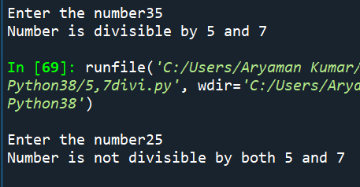

**5. Write a program to find the input year is leap year or not.**

**Code:**

**#Program to find out whether a given year is a leap year**

**n=int(input("Enter the year"))**

**if(n%100==0):**

**if(n%400==0):#If a leap year is also divisible by 100 then it has to**

**#be divisible by 400 to be a leap year**

**print("It is leap year")**

**else:**

**print("It is not a leap year")**

**elif(n%4==0):#If a year not divisible by 100 is divisible by 4 it is a**

**#leap year**

**print("It is leap year")**

**else:**

**print("It is not a leap year")**

**Output:**

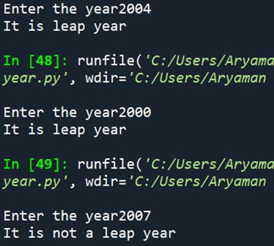

**6. Write a program in python to input three sides of a triangle and check whether the triangle is equilateral, isosceles or scalene .**

**Code:**

**#Program to determine the type of triangle from given three sides**

**a=int(input("Enter length of first side"))**

**b=int(input("Enter length of second side"))**

**c=int(input("Enter length of third side"))**

**if(a==b and b==c):**

**print("Equilateral triangle")**

**elif(a==b or b==c or c==a):**

**print("Isoceles triangle")**

**else:**

**print("Scalene triangle")**

**Output:**

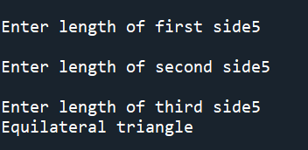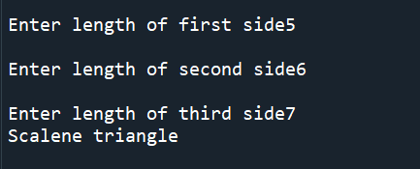

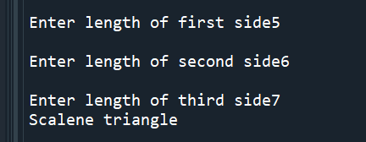

**7. Write a program in python to input three sides of a triangle and check whether it is right angled one.**

**Code:**

**#Program to check if given sides form a right angled triangle using pythagoras theorem**

**import math**

**a=int(input("Enter length of first side"))**

**b=int(input("Enter length of second side"))**

**c=int(input("Enter length of third side"))**

**if(c>a and c>b):**

**if(c^2==a^2+b^2):#We apply pythagoras theorem to see if the square of the largest side**

**#is equal to the sum of squares of the other two sides**

**print("Right angle triangle")**

**if(b>a and b>c):**

**if(b^2==a^2+c^2):**

**print("Right angle triangle")**

**if(a>b and a>c):**

**if(a^2==b^2+c^2):**

**print("Right angle triangle")**

**Output:**

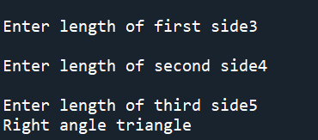 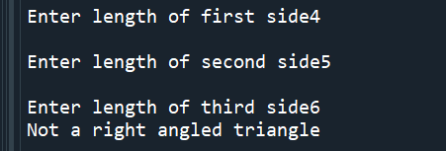

**8. Read a number, check if it is positive, negative or zero. Increment the number if it is positive, decrement if it is negative.**

**Code:**

**#Program checks whether a given number is positive,negative or zero and increments the number if it is positive and decrements it if negative.Number is unchanged if it is zero.**

**n=int(input("Enter the number"))**

**if(n>0):**

**n=n+1#If number is positive ,it is incremented**

**print(n)**

**elif(n<0):**

**n=n-1#If number is negative it is decremented**

**print(n)**

**else:**

**print(n)**

**Output:**

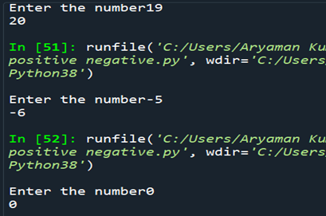

**9. Create a simple calculator.**

**Code:**

**#Program to make a simple calculator that can add,subtract,multiply and divide two numbers**

**a=int(input("Enter first number"))**

**b=int(input("Enter second number"))**

**ch=int(input("Enter your choice 1.Addition,2.Subtraction,3.Multiplication,4 division"))**

**if(ch==1):**

**c=a+b**

**print("Result",c)**

**if(ch==2):**

**c=a-b**

**print("Result",c)**

**if(ch==3):**

**c=a*b**

**print("Result",c)**

**if(ch==4):**

**c=a/b**

**print("Result",c)**

**Output:**

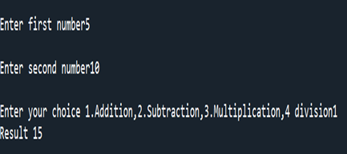 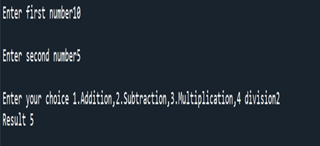

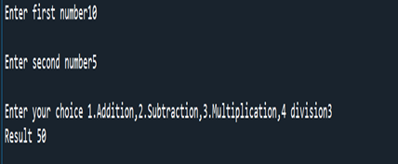 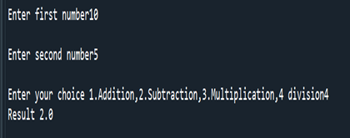

**10. Estimate the Grade based on the marks obtained by a student.**

**Code:**

**#Program to calculate grade of student based on marks**

**marks=int(input("Enter the marks of the student"))**

**if(marks>=90):**

**print("A")**

**elif(marks>=70 and marks<90):**

**print("B")**

**elif(marks>=50 and marks<70):**

**print("C")**

**elif(marks>=35 and marks<50):**

**print("D")**

**else:**

**print("E")**

**Output:**

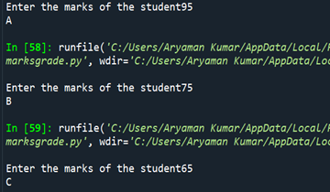 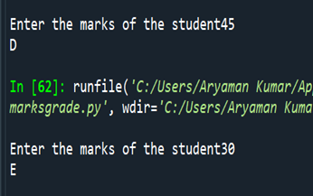

**11. Obtain a character, check if it is lower case, uppercase or digit.**

**Code:**

**#Program to find whether input character is uppercase,lowercase or digit**

**a=input("Enter character")**

**if(a.islower()==True):**

**print("Character is lowercase")**

**elif(a.isupper()==True):**

**print("Character is Uppercase")**

**elif(a.isdigit()==True):**

**print("Character is a digit")**

**Output:**

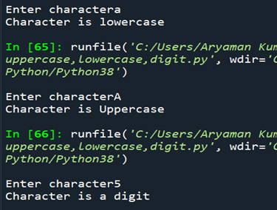

**12. Find the largest of 3 numbers.**

**Code:**

**#Program to find out the greatest number among three numbers**

**n1=int(input("Enter first number"))**

**n2=int(input("Enter second number"))**

**n3=int(input("Enter third number"))**

**if(n1>n2 and n1>n3):**

**print(n1,"n1 is greatest")**

**elif(n2>n1 and n2>n3):**

**print(n2,"n2 is greatest")**

**else:**

**print(n3,"n3 is greatest")**

**Output:**

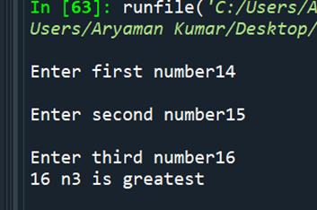

**13. Obtain a input from the user and display the corresponding data types (primitive and compound data type)**

**While Loop**

1. **Compute Exponentiation (power of a number) without using ** operator.**

**#program to compute exponentiation without** operator**

**n=int(input("Enter the number"))**

**i=int(input("Enter power of number"))**

**count=0**

**expo=1**

**while(count<i):**

**#number is multiplied by itself for the number of times**

**expo =expo*n #specified by the user**

**count=count+1**

**print(expo)**

**Output:**

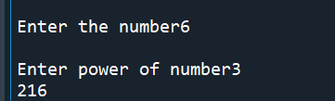

1. **Write a program in python to print all the two digit numbers which are either divisible by 3 or by 4.**

**#Program to c=print all two digit numbers divisible by 3 or 4**

**n=10**

**while(n<100):**

**if(n%3==0):#divisibility by 3 is checked first and then divisibility by 4**

**print(n)**

**elif(n%4==0):**

**print(n)**

**n=n+1**

**Output:**

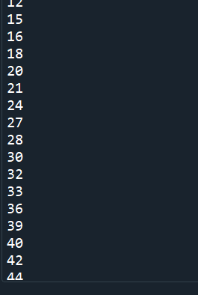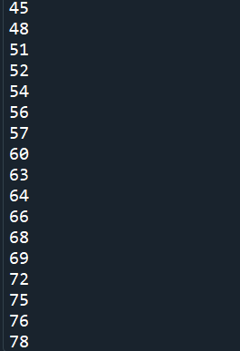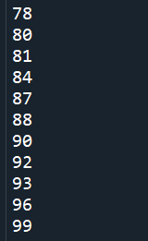

1. **Write a program in python to print the sum of all the digits of a number.**

**#Program to find the sum of digits**

**n=int(input("Enter the number")**

**rem=0**

**sum=0**

**while(n>0):**

**rem=n%10**

**sum=sum+rem**

**n=n//10**

**print("Sum of digits",sum)**

**Output:**

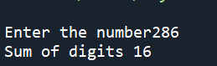

1. **Perform the division operation and find the quotient and remainder values. (without using /, // % operators) .**

**#Division without using /,// or %**

**a=int(input("Enter number"))**

**b=int(input("Enter divisor"))**

**q=0**

**sub=a**

**while(sub>0):**

**sub=sub-b**

**q=q+1#quotient is number of times the loop runs until divisor can no more be subtracted from original number**

**rem=a-b*(q)**

**if(rem<0):#To ensure remainder is not negative and product of quotient and divisor doesnt exceed number**

**rem=rem+b**

**q=q-1**

**print("Quotient",q)**

**print("Remainder",rem)**

**Output:**

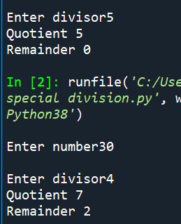

1. **Check whether the given number is palindrome or not .**

**Code:**

**#Program to check whether a given number is palindrome number**

**a=int(input("Enter the number"))**

**dig=0**

**sum=0**

**temp=a**

**while(a>0):**

**dig=a%10**

**a=a//10**

**sum=sum*10+dig**

**if (temp==sum):**

**print("Palindrome number")**

**else:**

**print("Not a palindrome number")**

**Output:**

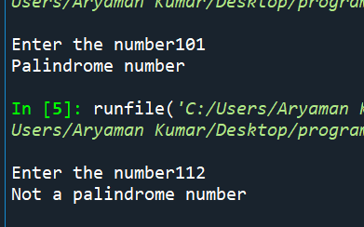

1. **Check whether the given number is Armstrong number or not.**

**Code:**

**#Program to find whether a given number is armstrong number or not**

**n=int(input("Enter the number"))**

**rem=0**

**sum=0**

**temp=n**

**while(n>0):**

**rem=n%10**

**sum=sum+rem**3#Calculating sum of cubes**

**n=n//10**

**if(sum==temp):#If original number equals sum of cubes of its digit it is armstrong number**

**print("It is a armstrong number")**

**else:**

**print("It is not armstrong number")**

**Output:**

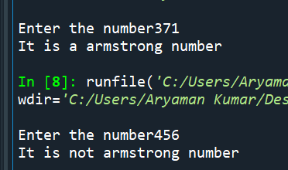

1. **Compute the GCD of two numbers.(Euclidean Method and using common factors)**

**Code:**

**#Program to find HCF of a number using euclidean algorithm and common factor method**

**a=int(input("Enter first number"))**

**b=int(input("Enter second number"))**

**x=a**

**y=b**

**c=1**

**i=1**

**fact=0**

**#using euclidean algorithm**

**while(b>0):**

**c=a%b**

**a=b**

**b=c**

**print(a,"is HCF by Euclidean method")**

**#Using common factor method**

**while(x//i>0 and y//i>0):**

**if(x%i==0 and y%i==0):**

**fact=i**

**i=i+1**

**print(fact,"is HCF by common factor method")**

**Output:**

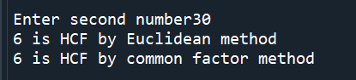

1. **Take integer inputs from user until he/she presses q (Ask to press q to quit after every integer input ). Print average and product of all numbers.**

**Code:**

**#Program to find the average and product of numbers entered by the user**

**inp='true'**

**avg=0**

**sum=0**

**prod=1**

**count=1**

**while(inp=='true'):**

**n=int(input("Enter number"))**

**sum=sum+n**

**avg=sum/count**

**prod=prod*n**

**count=count+1**

**e=input("If you wish to continue,press any key ,if you wish to exit press q")**

**if(e=='q'):**

**inp='false'**

**print("Average",avg)**

**print("Product",prod)**

**Output:**

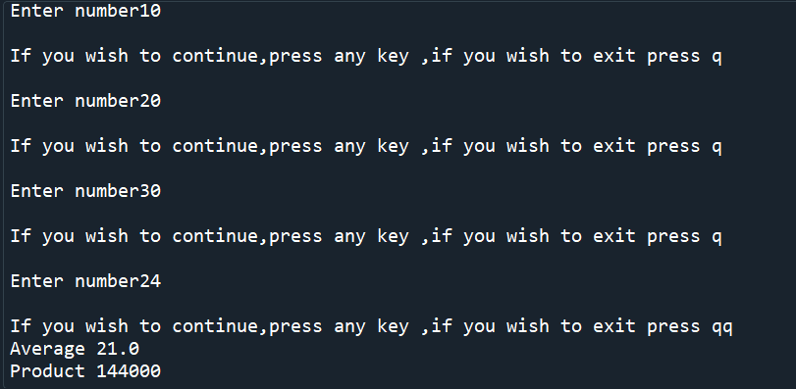

1. **Find the square root of a number. (Newton’s method)**

**Code:**

**#Program to find root of a number using Newtons method**

**root=0**

**n=int(input("Enter the number"))**

**x=n**

**a=True**

**while(a==True):#root=x+n/x where x is the assumed value of the root and n is the number**

**root=0.5*(x+n/x)**

**if((root-x)<0):**

**root2=(root-x)*-1**

**if(root2<1):**

**a=False**

**x=root**

**print(int(root))**

**Output:**

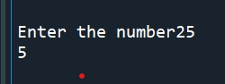

**For Loop**

**1. Write a Python program to construct the following pattern, using a nested for loop.**

**a)**

**\***

**\*\*\***

**\*\*\*\***

**\*\*\*\*\***

**\*\*\*\***

**\*\*\***

**\*\***

**\***

**Code:**

**for i in range(0,6):**

**for j in range(0,i):**

**print("*",end='')**

**print('')**

**for i in range(4,0,-1):**

**for j in range(i,0,-1):**

**print('*',end='')**

**print('')**

**Output:**

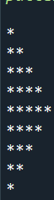

**b)**

**1**

**21**

**321**

**4321**

**54321**

**Code:**

**for i in range(0,6):**

**for j in range(i,0,-1):**

**print(j,end='')**

**print('')**

**Output:**

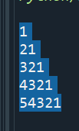

**c)**

**1**

**1 1**

**1 2 1**

**1 3 3 1**

**1 4 6 4 1**

**1 5 10 10 5 1**

**1 6 15 20 15 6 1**

**Code: """**

**#Program to display pascals triangle up till given row**

**from math import factorial**

**n=int(input("Enter the number of rows of Pascals triangle required"))**

**for i in range(n):**

**for j in range(1,n-i+1):**

**print(end=" ")**

**for j in range(0,i+1):**

**print(int(factorial(i)/(factorial(j)*factorial(i-j))),end=" ")**

**print("")**

**Output:**

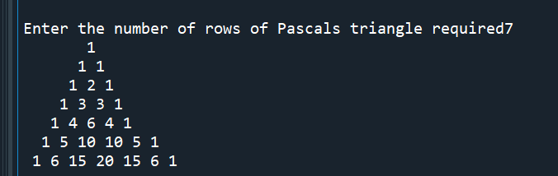

**2. Write a Python program that accepts a word from the user and reverse it.**

**Code:**

**#Program to accept a word from the user and reverse it**

**str1=input("Enter text")**

**rev=str1[::-1]**

**print("reversed text",rev)**

**Output:**

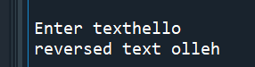

**3. Write a Python program to count the number of even and odd numbers from**

**a series of numbers. Sample numbers : numbers = (1, 2, 3, 4, 5, 6, 7, 8, 9)**

**Code:**

**#Program to find odd and even numbers in given series of numbers**

**numbers = (1, 2, 3, 4, 5, 6, 7, 8, 9)**

**evencount=0**

**oddcount=0**

**for i in range(0,len(numbers)):**

**if(numbers[i]%2==0):**

**evencount=evencount+1**

**else:**

**oddcount=oddcount+1**

**print("Number of even numbers",evencount)**

**print("Number of odd numbers",oddcount)**

**Output:**

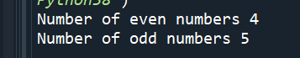

**4. Write a Python program that prints each item and its corresponding type**

**from the following list.**

**Sample List : datalist = [1452, 11.23, 1+2j, True, 'w3resource', (0, -1), [5, 12],**

**{"class":'V', "section":'A'}]**

**Code:**

**#Program to display the datatype of all the elements of the given list**

**datalist = [1452, 11.23, 1+2j, True, 'w3resource', (0, -1), [5, 12], {"class":'V', "section":'A'}]**

**for i in range(0,len(datalist)):**

**print(type(datalist[i]))**

**Output:**

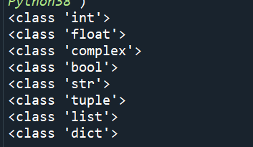

**5. Write a Python program that prints all the numbers from 0 to 6 except 3 and 6. Note : Use 'continue' statement.**

**Code:** **#Program to print every number in the given range except 3 and 6**

**for i in range(0,6):**

**if(i==3 or i==6):**

**continue**

**else:**

**print(i)**

**Output:**

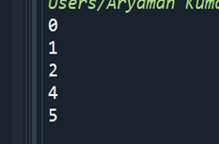

**6. Write a Python program which iterates the integers from 1 to 50. For multiples of three print "Fizz" instead of the number and for the multiples of**

**five print "Buzz". For numbers which are multiples of both three and five**

**print "FizzBuzz".**

**Code:**

**#Program iterates from 1 to 50 and displays fizz for multiples of 3 ,buzz for multiples of 5 and fizzbuzz for multiples of both**

**for i in range (1,51):**

**if(i%3==0):**

**print("fizz")**

**if(i%5==0):**

**print("buzz")**

**if(i%3==0 and i%5==0):**

**print("fizzbuzz")**

**else:**

**continue**

**Output:**

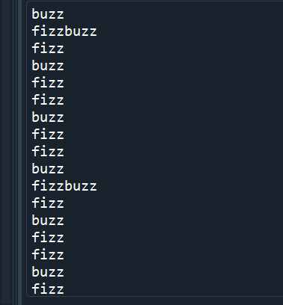

**7. Write a Python program to find numbers between 100 and 400 (both included) where each digit of a number is an even number. The numbers obtained should be printed in a comma-separated sequence.**

**Code:**

**#Program to display numbers with only even digits between 100 to 400**

**rem=0**

**sum=0**

**l=[ ]**

**q=''**

**for i in range(1,401):**

**n=i**

**while(n>0):#loop to check if digits are even**

**rem=n%10**

**if(rem%2!=0):#If digit is odd loop is broken**

**q=False**

**break**

**else:**

**q=True**

**n=n//10**

**if(q==True):**

**l.append(i)#number is stored in list**

**for i in range(0,len(l)):**

**print(l[i])**

**Output:**

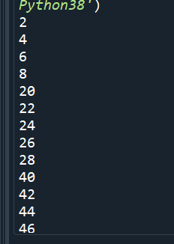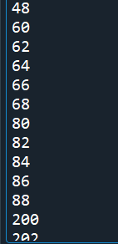 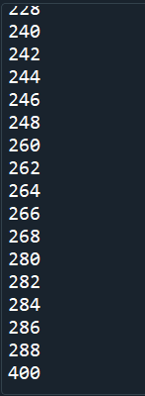

**8. Write a Python program to create the multiplication table (from 1 to 10) of**

**a number.**

**Code:**

**#Program to display multiplication table of a number from 1 to 10**

**n=int(input("Enter the number"))**

**for i in range(1,10):**

**print(n,"x",i,"=",n*i)**

**Output:**

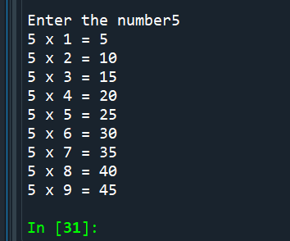

**9. Find the sum of series:**

**a. 1 + 1/2 + 1/3 + ….. + 1/N**

**#Program to find sum of series 1 + 1/2 + 1/3 + ….. + 1/N**

**N=int(input("Enter last term of series"))**

**sum=0**

**for i in range(1,N+1):**

**sum=sum+1/i**

**print("Sum is",sum)**

**Output:**

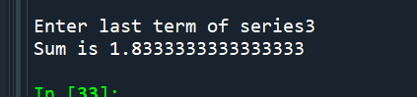

**b. 1 + x^2/2 + x^3/3 + … x^n/n**

**Code:**

**#Program to find sum of series 1 + x^2/2 + x^3/3 + … x^n/n**

**N=int(input("Enter last term of series"))**

**x=int(input("Enter the value of x"))**

**sum=1**

**for i in range(2,N+1):**

**sum=sum+(x^i)/i**

**print("Sum is ",sum)**

**output:**

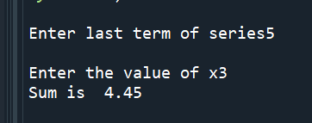

**10.Classify the given number is prime or composite number.**

**Code:**

**Program to find whether a number is prime number or composite number**

**q=False**

**n=int(input("Enter the number"))**

**if(n==1):**

**print("Number is a unique number")**

**for i in range(2,n):**

**if(n%i==0):**

**print("Number is a composite number")**

**break**

**else:**

**q=True**

**if(q==True):**

**print("Number is a prime number")**

**Output:**

